Department of Computer Science & Information Technology

Academic Session 2023-24

Programme Name: B. Tech TYCS

Semester: VI

Symbiosis Institute of Technology

CA-3 Report

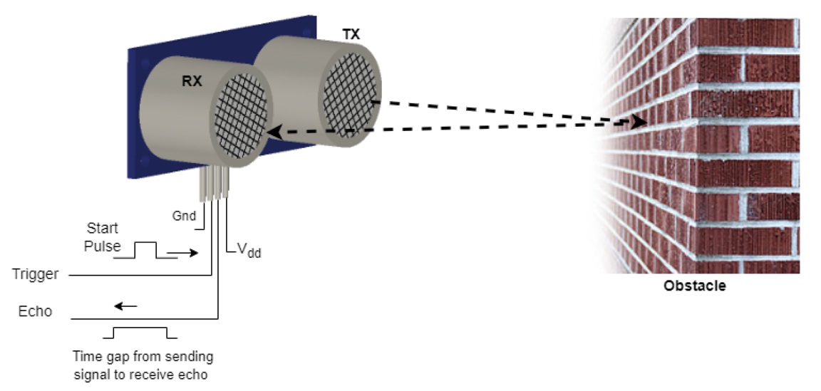

Under the Guidance of  
**Dr. Subham Joshi**

**Group Members:**

|  |  |  |  |
| --- | --- | --- | --- |
| **Sr. No.** | **Name** | **PRN** | **Division** |
| 1 | Maimuna Khatoon | 21070122089 | CS-B |
| 2 | Nandita Namboodiri | 21070122100 | CS-B |
| 3 | Pranidhi Patel | 21070122119 | CS-B |
| 4 | Saksham Gupta | 21070122137 | CS-B |

**IoT Project : Smart Cane For Specially-Abled People**

**Abstract:**

The advent of Internet of Things (IoT) technology has paved the way for innovative solutions to address challenges faced by individuals with disabilities, particularly in the realm of healthcare. Conventional aids such as the white cane have long served as symbols of autonomy, yet are limited in their ability to provide real-time obstacle detection and emergency assistance. In response, this project proposes the development of a Smart IoT Walking Stick tailored for the specially-abled community.

Leveraging Internet of Things (IoT) technology, the prototype integrates hardware components such as Node MCU, Arduino, ultrasonic sensors, and a buzzer, along with Wi-Fi connectivity and communication protocols, the device offers real-time obstacle detection and alert systems. Furthermore, it utilizes location tracking capabilities to provide proactive safety measures, ensuring timely assistance in emergency situations. Through a user-centered design approach, the smart walking stick aims to enhance the autonomy, safety, and peace of mind of specially abled individuals, contributing to their greater independence and societal inclusivity. Through continuous refinement and collaboration, this project strives to redefine the boundaries of accessibility and inclusivity for individuals with visual impairments, fostering a more inclusive and equitable society.

**Introduction:**

In a world increasingly reliant on navigation and interaction, specially-abled individuals disabilities face challenges in their day-to-day lives. Simple tasks that many take for granted, such as navigating city streets or avoiding obstacles, can become daunting and potentially hazardous for especially abled individuals. As technology continues to evolve, there arises an opportunity to bridge this gap through innovative solutions that empower and assist especially abled individuals.

Our project aims to address this pressing need by leveraging the capabilities of Internet of Things technology to create a smart walking stick tailored specifically for the visually impaired. This walking stick serves as more than just a mobility aid; it embodies a holistic approach to enhancing safety, autonomy, and peace of mind for its users.At its core, our smart walking stick utilizes a combination of cutting-edge hardware components and sophisticated software algorithms to provide real-time obstacle detection and alert systems. integration of Node MCU, Arduino, ultrasonic sensors, and a buzzer, our device can detect obstacles within a considerable range and promptly notify the user through audible alerts. The ultrasonic sensor, with a detection range set at 30cm, ensures that obstacles are detected well in advance, allowing the user to navigate safely.

Crucially, our solution goes beyond mere obstacle detection. By harnessing the power of Wi-Fi connectivity and communication protocols such as HTTPS, our walking stick can seamlessly connect to the internet and access essential services. This connectivity enables functionalities such as retrieving the user's public IP address and obtaining location-based information, which are invaluable in emergency situations.

Moreover, our device features real time location and sends alerts to the user's designated contacts and relevant authorities. This proactive safety approach ensures that help is readily available whenever it is needed, providing both users and their loved ones with peace of mind. The system is made to be small and light, and is used with the white cane to keep specially abled people safe. In essence, our project represents a convergence of technological innovation and social responsibility. By prioritizing accessibility, inclusivity, and user-centered design, we aspire to make meaningful contributions to the lives of the visually impaired community. Through continuous refinement and collaboration, we believe that our smart walking stick has the potential to transform the way specially individuals navigate the world, empowering them to live with greater independence, dignity, and confidence.

**Literature Survey:**

**Methadology:**

**Hardware Components:**

The smart cane prototype utilizes the following key hardware components:

* Node MCU: The main controller; a low-cost open-source IoT platform based on ESP8266 Wi-Fi module. We use it to enable wireless connectivity.
* Arduino Uno: A microcontroller board used for programming and controlling the sensor and buzzer components.
* Ultrasonic Sensors: Used for obstacle detection. It sends out sound waves and measures how long it takes for them to bounce back.
* Buzzer: Provides audible alerts to notifies of detected obstacles to the user

**Software Components:**

The system incorporates the following software components:

* Arduino IDE: Used for programming the Arduino Uno microcontroller to handle sensor data and control the buzzer.
* ThingSpeak API: A cloud-based IoT platform used for storing and retrieving location data from the smart cane device.
* IP-API: A third-party API utilized for obtaining the device's public IP address and corresponding location information.

**System Architecture:**

The smart cane system follows a modular architecture, comprising two main modules:

1. **Obstacle Detection Module:** This module is responsible for detecting obstacles using ultrasonic sensors and providing audible feedback through a buzzer. The Arduino Uno microcontroller processes the sensor data and controls the buzzer based on the detected distance.
2. **Location Tracking and Monitoring Module:** This module leverages the Node MCU and Wi-Fi connectivity to obtain the device's public IP address and retrieve location information from IP-API. The obtained location data is then transmitted to the ThingSpeak platform for storage and real-time monitoring.

**Work:**

1. **Ultrasonic sensor:**

This Arduino code sets up an obstacle alarm system using an ultrasonic sensor. It initializes pins for the sensor's trigger, echo, and a buzzer. In the loop function, it quickly sends a signal to the sensor and then measures how long it takes for the signal to bounce back. It figures out how far away any obstacles are based on the time calculated. If the distance is 30 centimetres or less, it activates the buzzer and prints a message indicating an "Obstacle Open". If the distance exceeds 30 centimetres, it prints "Obstacle Closed" and deactivates the buzzer. This process repeats continuously, providing real-time feedback about obstacle presence and distance through the serial monitor.

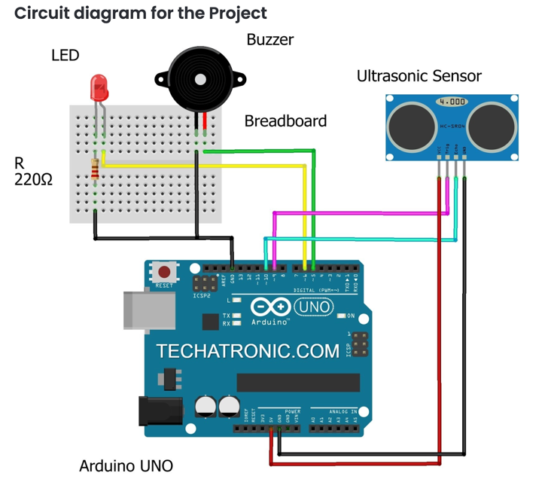

Circuit diagram of ultrasonic sensor

1. **NODE MCU:**

This Arduino code is designed to gather location data and update it on a ThingSpeak channel. It includes Wi-Fi setup using an ESP8266 module, and it connects to the Wi-Fi network specified by the `ssid` and `pass` variables. The code retrieves the device's local IP address and public IP address using the `WiFi.localIP()` and `GetExternalIP()` functions, respectively. It then makes an HTTP request to `ip-api.com` to fetch JSON data containing latitude and longitude coordinates based on the public IP address. The latitude and longitude values are extracted from the JSON response and sent to ThingSpeak as field data. Additionally, a status message is set to "✅" indicating successful data transmission. The code continuously loops, updating the ThingSpeak channel every 20 seconds.

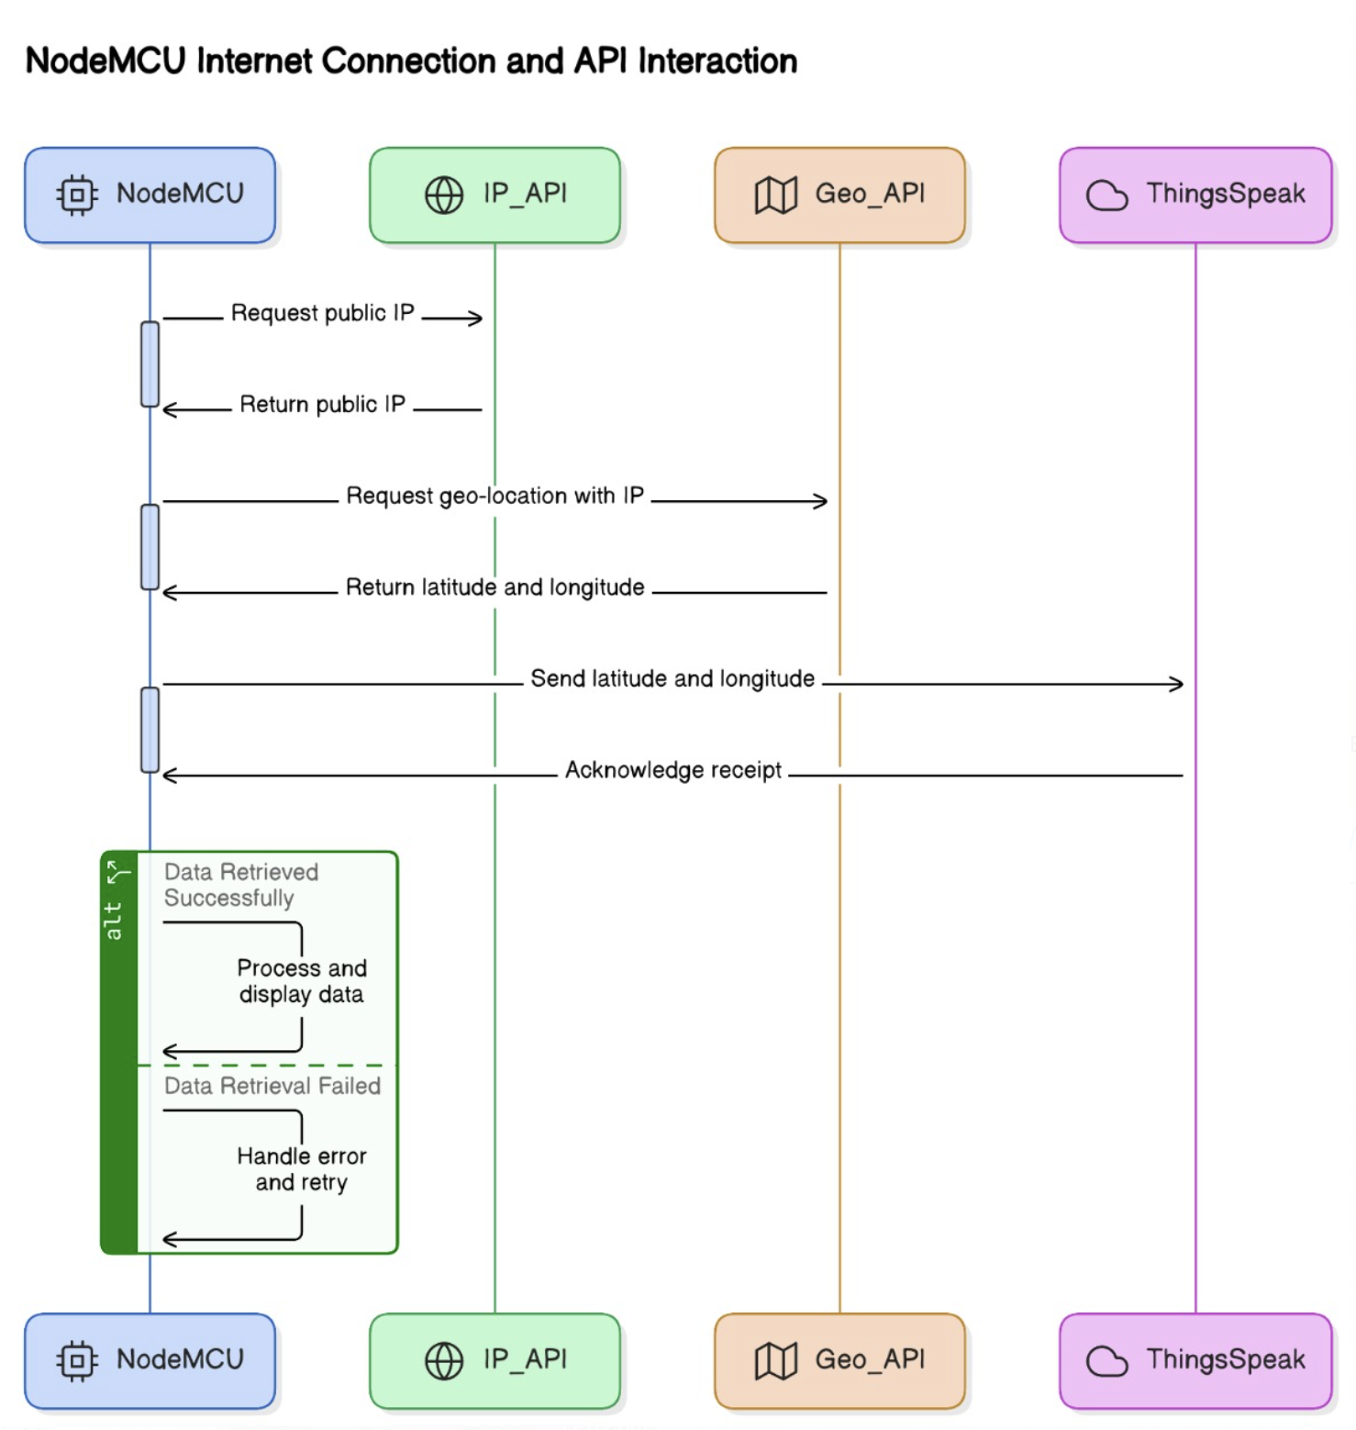

Node MCU Working

**Code:**

1. **NODE MCU**

1. **Obstacle Alarm Using Arduino UNO and Ultrasonic Sensor**

**Integration with thinkspeak:**

**Testing:**

At this stage, the Smart Cane project has made significant progress towards its goal of developing an IoT-enabled mobility aid. Through information gathering, the device has been calibrated to detect obstacles at specific distances ranging from 0.5m to 30cm.

The Smart Cane aims to empower specially-abled individuals by providing them with enhanced navigation capabilities. Users can activate the device with a simple switch, enabling them to detect obstacles using ultrasonic sensors coupled with motor feedback. Additionally, the integration of node MCU technologies allows users to share their location with guardians or parents, enhancing security and peace of mind.

Use case diagram


Use case diagram

The project currently consists of two modules: obstacle detection with sound and vibrations, and real-time monitoring using Node MCU. Through continuous refinement and user feedback, the Smart Cane is evolving into a versatile and reliable aid for specially abled individuals. Initial research results indicate high levels of satisfaction among users, highlighting the positive impact of the system on their safety and independence.

**Strengths of the system:**

1. Detect obstacles at a distance of 0.5cm-30cm.

2. provides accurate information of the user

3. Provides autonomy, safety, and peace of mind to users and their loved ones.

**Weakness:**

The system has weaknesses, such as:

1. Susceptible to water damage.

2. Prone to compound damage if dropped.

**Result:**

The Smart Cane project has achieved significant milestones in the development of an IoT-enabled mobility aid for specially abled individuals. Through rigorous testing and iteration, the project has demonstrated several key outcomes:

**1. Obstacle Detection Accuracy:** The prototype has shown reliable performance in detecting obstacles within the specified range of 0.5m to 30cm. Using ultrasonic sensors coupled with Arduino control, the Smart Cane provides timely alerts to users, enabling them to navigate safely in their environment.

**2. Location Tracking and Monitoring:** Integration of Node MCU and Wi-Fi connectivity allows the Smart Cane to retrieve the user's public IP address and obtain real-time location information. This feature enhances user safety by enabling proactive assistance in emergency situations, ensuring that help is readily available when needed.

**3. User Satisfaction:** Initial feedback from users has been overwhelmingly positive, indicating a high level of satisfaction with the functionality and effectiveness of the Smart Cane. Users appreciate the device's ability to enhance their autonomy and peace of mind, as well as its potential to alleviate concerns for their guardians or parents.

**4. Identified Limitations:** Despite its successes, the project has identified certain limitations, including susceptibility to water damage and potential compound damage from falls. These limitations highlight areas for further improvement and refinement in future iterations of the Smart Cane prototype.

Overall, the results of the project demonstrate the feasibility and potential impact of leveraging IoT technology to address the unique challenges faced by specially abled individuals. By prioritizing accessibility, inclusivity, and user-centered design, the Smart Cane project represents a significant step forward in advancing assistive technology and fostering a more inclusive society.

**Conclusion:**

The Smart Cane project represents a significant milestone in the realm of assistive technology, specifically designed to cater to the needs of specially abled individuals. Through the integration of Internet of Things (IoT) technology, the prototype offers a comprehensive solution for real-time obstacle detection, location tracking, and emergency assistance.

Throughout the development process, our team has demonstrated a commitment to user-centered design and continuous improvement. By leveraging cutting-edge hardware components such as Node MCU, Arduino, and ultrasonic sensors, coupled with sophisticated software algorithms, we have created a versatile and reliable mobility aid for the visually impaired community.

The positive feedback received from initial testing underscores the potential impact of the Smart Cane on the safety and independence of its users. However, it is important to acknowledge certain limitations, such as susceptibility to water damage and potential compound damage from falls.

Moving forward, further refinement and iteration will be necessary to address these challenges and enhance the durability and reliability of the device. Additionally, efforts to raise awareness and promote adoption of the Smart Cane among the target audience will be crucial for maximizing its societal impact.

In conclusion, the Smart Cane project exemplifies the transformative potential of technology in improving the lives of individuals with disabilities. By prioritizing accessibility, inclusivity, and innovation, we are proud to have contributed to the advancement of assistive technology and the creation of a more inclusive society.

**References:**

[1] October 2017International Journal of Engineering and Technology 9(5):3435-3447

DOI:10.21817/ijet/2017/v9i5/170905302

[2] Sant, S., Salunkhe, M., Shah, K., Kumawat, G., & Palinje, M. Smart Cane: A Machine Learning-Powered Assistive Device.

[3] Ahmed, F., Tasnim, Z., Rana, M., & Khan, M. M. (2022, June). Development of low cost smart cane with GPS. In 2022 IEEE World AI IoT Congress (AIIoT) (pp. 715-724). IEEE.

[4] P. B, S. P. Y, S. D and M. Dakshayini, "IoT Based Smart Blind Stick Using GPS and GSM Module," 2022 Fourth International Conference on Cognitive Computing and Information Processing (CCIP), Bengaluru, India, 2022, pp. 1-4, doi: 10.1109/CCIP57447.2022.10058668. keywords: {GSM;Navigation;Roads;Blindness;Information processing;Acoustics;Security;Smart Blind Stick;Ultrasonic sensor;GPS;GSM},

[5] Ghani, F. A., & Zariman, A. (2019). Smart cane based on IoT. International Journal of Education, Science, Technology, and Engineering, 2(1), 12-18.